**Signal Processing of single and multi dimensional signals**

**Homework 1 – Plots**

*Analytical questions solutions is in the pdf “HW1”(scanned documet).

Submitted by:

Yotam Leibovitch, ID: 204095632

Asaf Bar-El, ID: 305794653

**Question 1**

1.2.

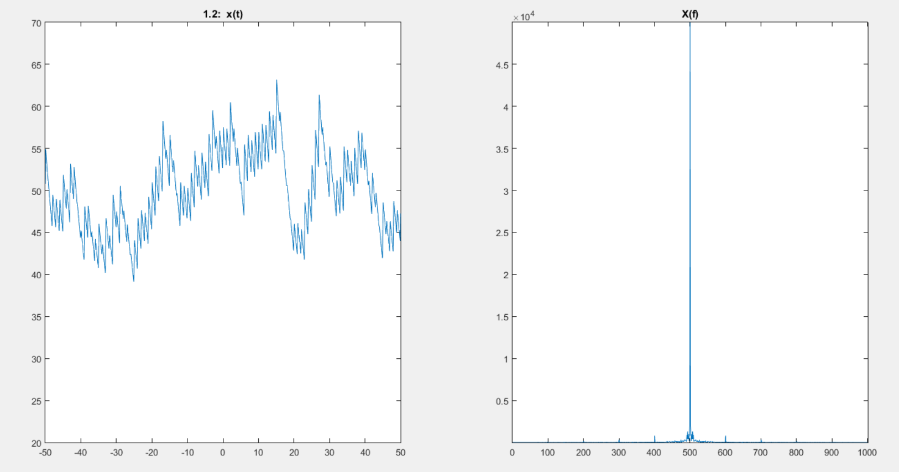

1.3.

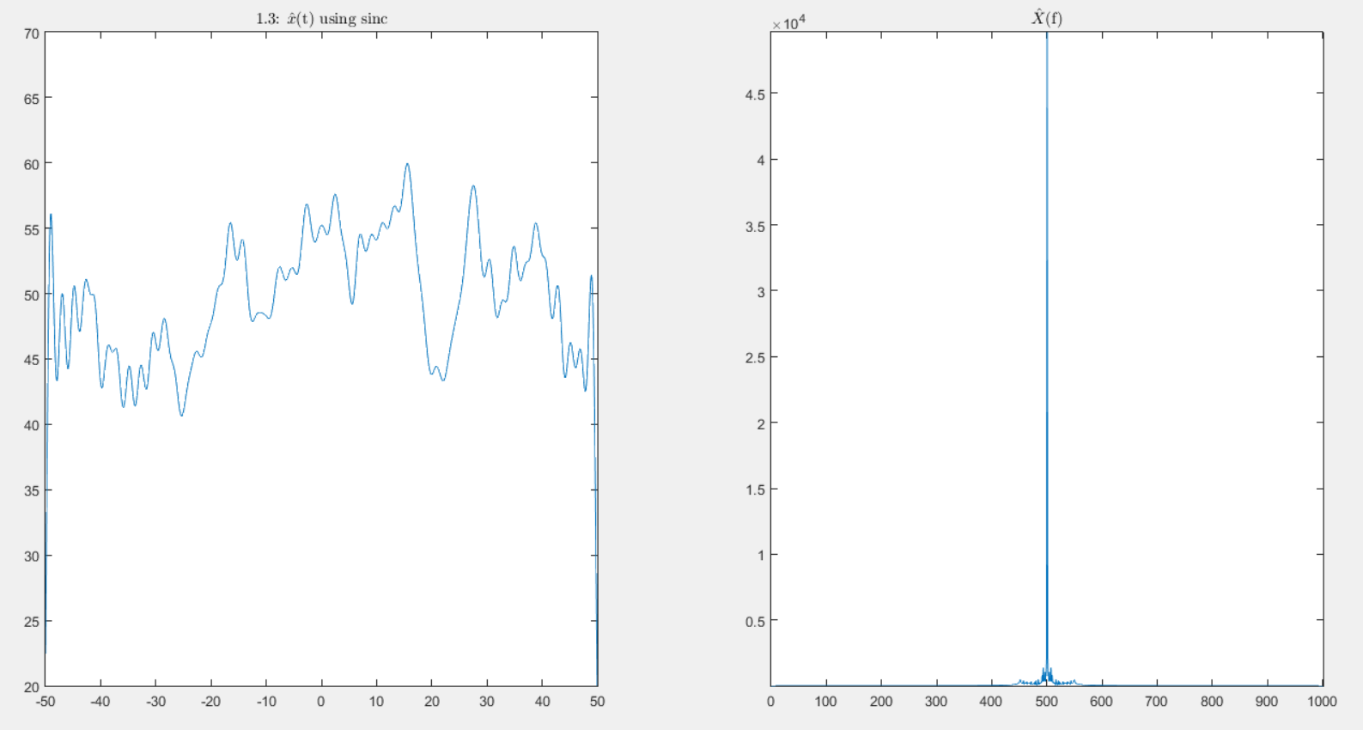

1.5.

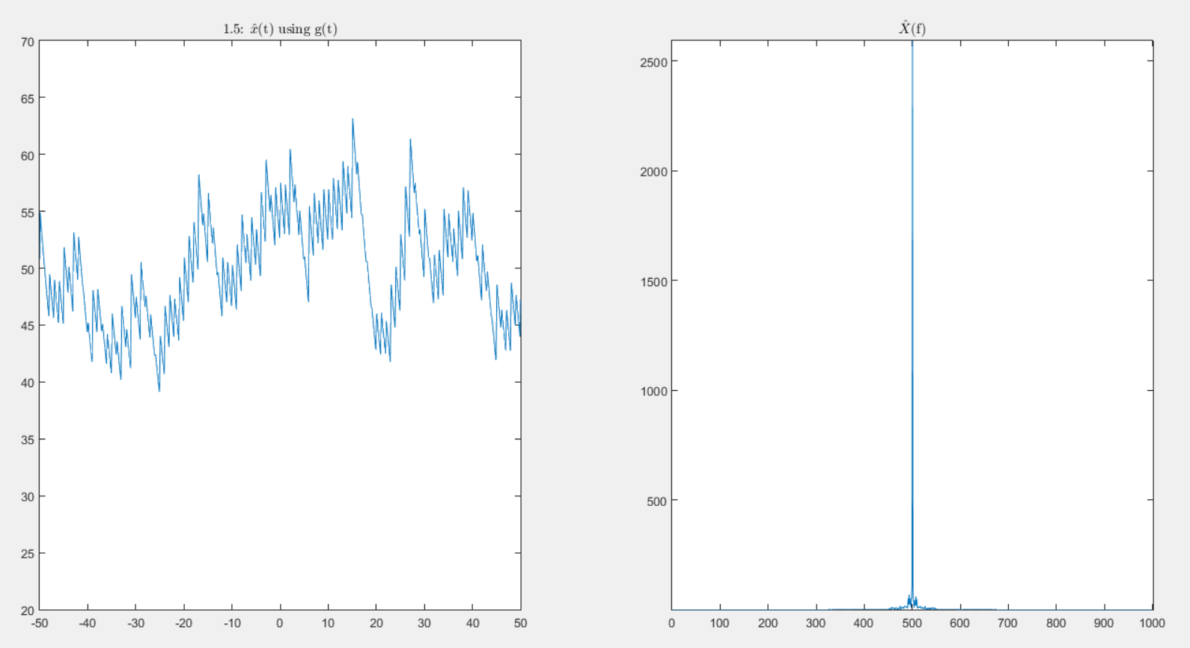

**Question 2**

2.2.a

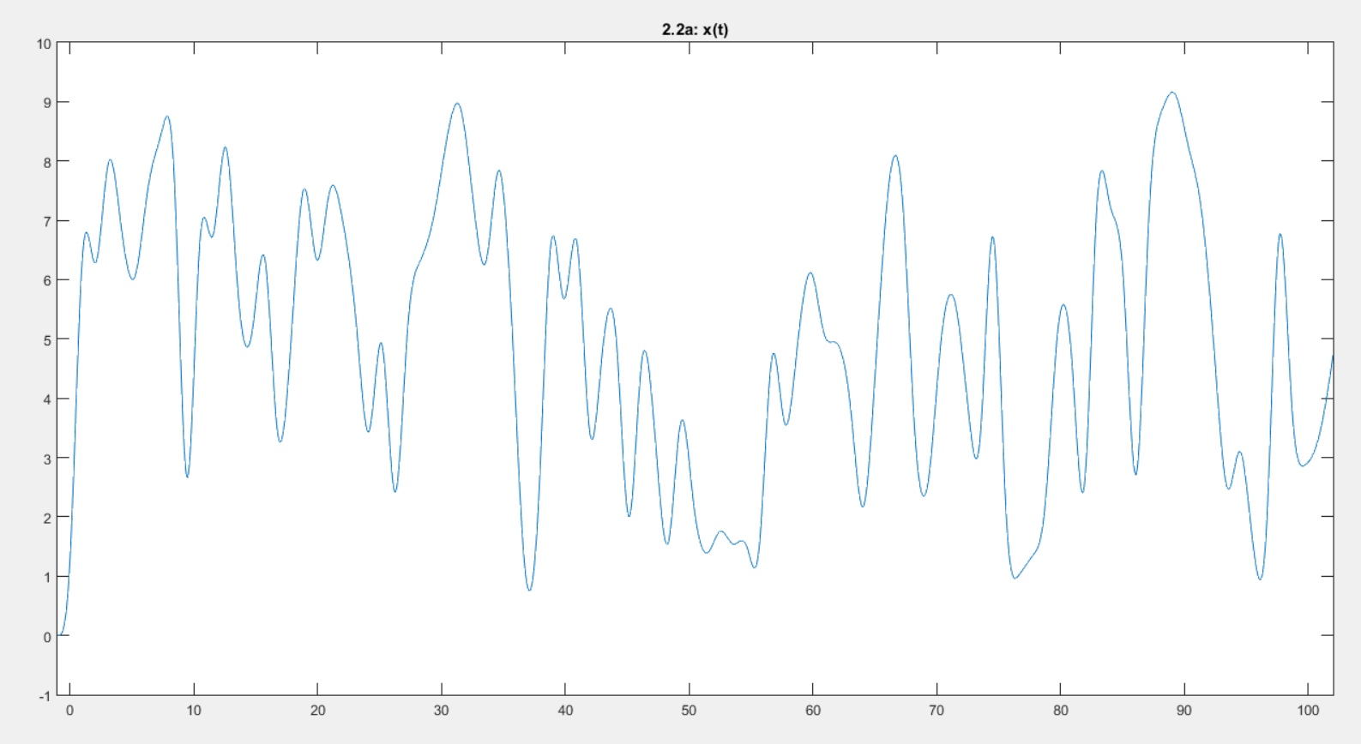

2.2.b

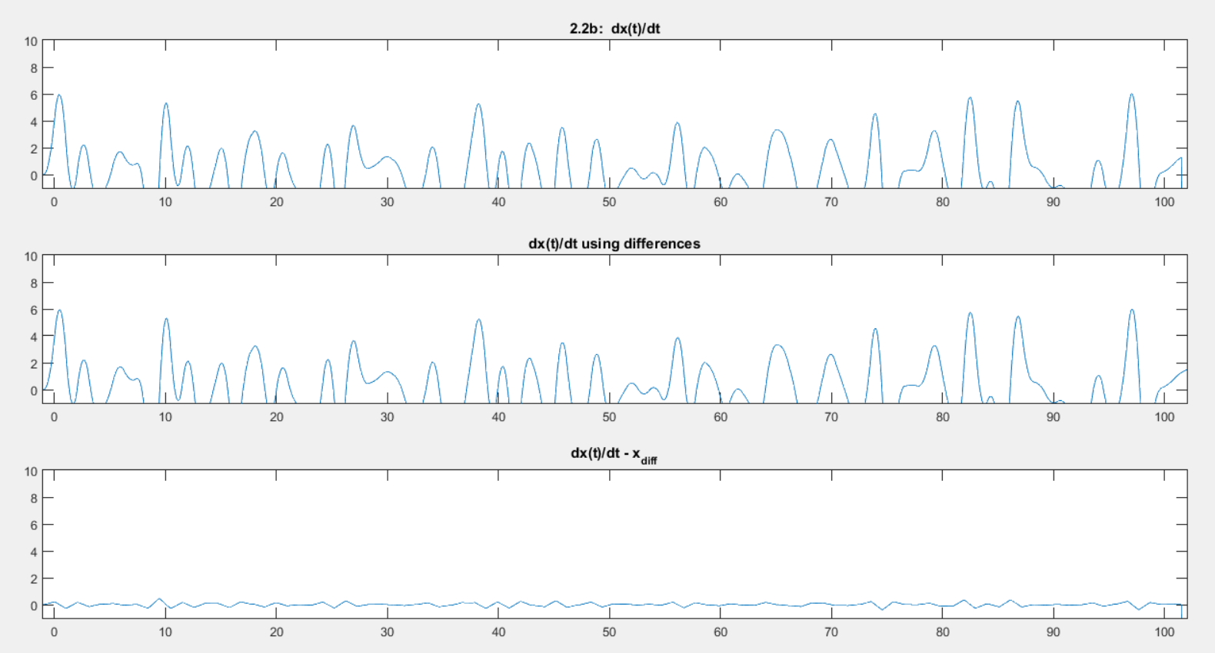

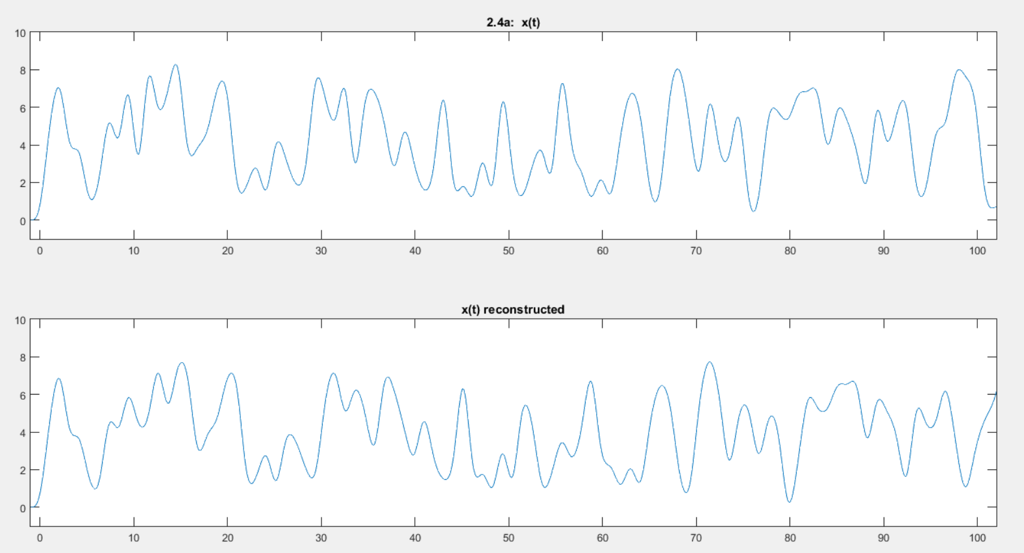2.4.a

2.5.b

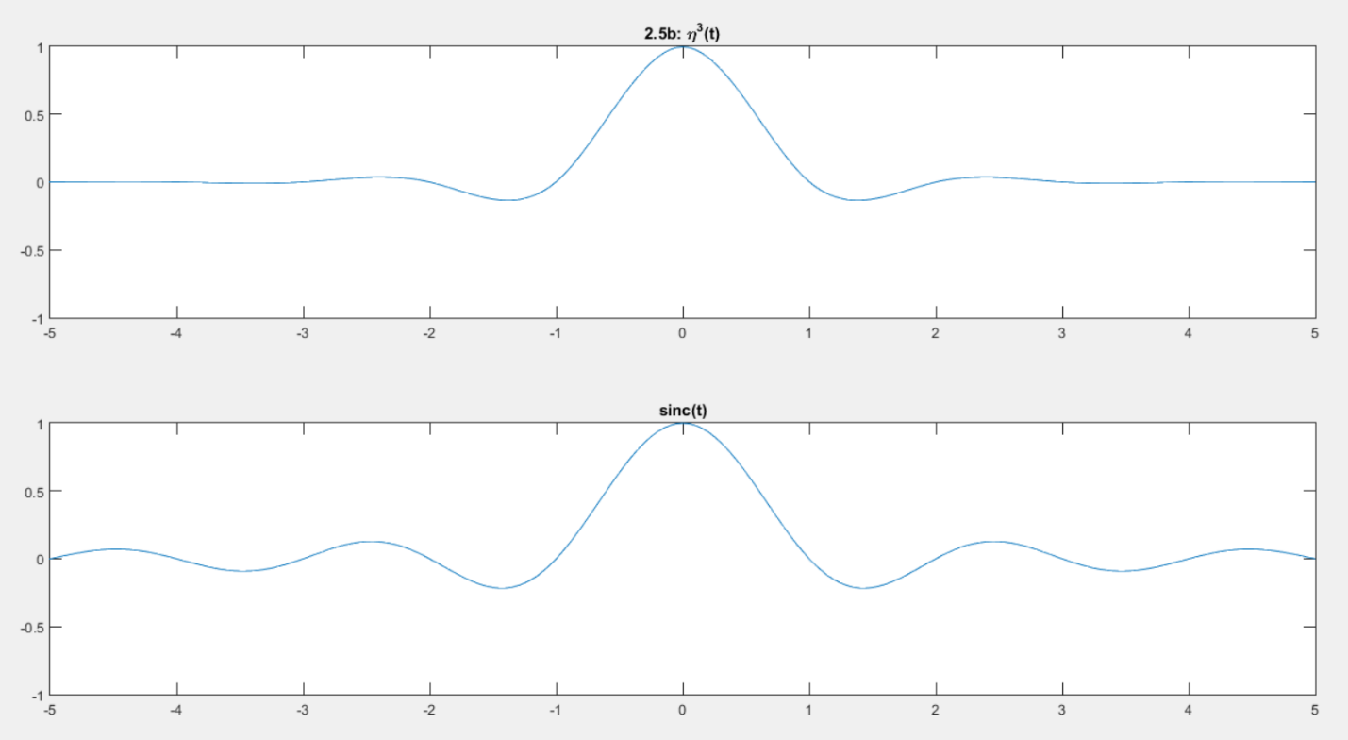

2.6.b

2.7.b





